1. 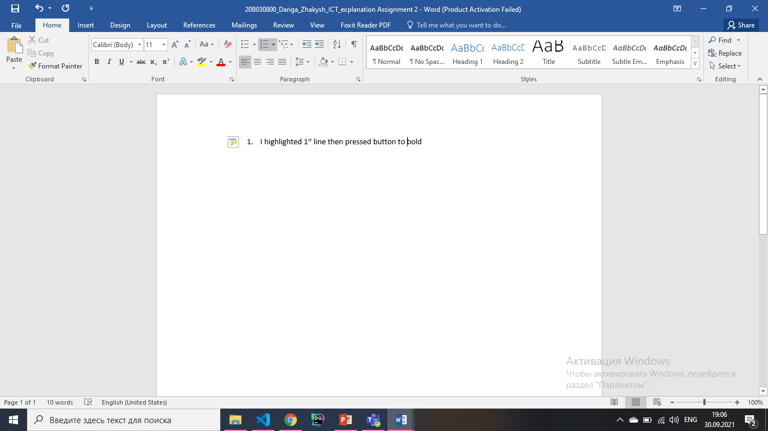I highlighted 1st line then pressed button to bold and

Chose 16 from rectangle, which I underline in this picture;

Then I pressed centering button:



1. I highlighted 1st paragraph then pressed button to bold as in 1st task.
2. 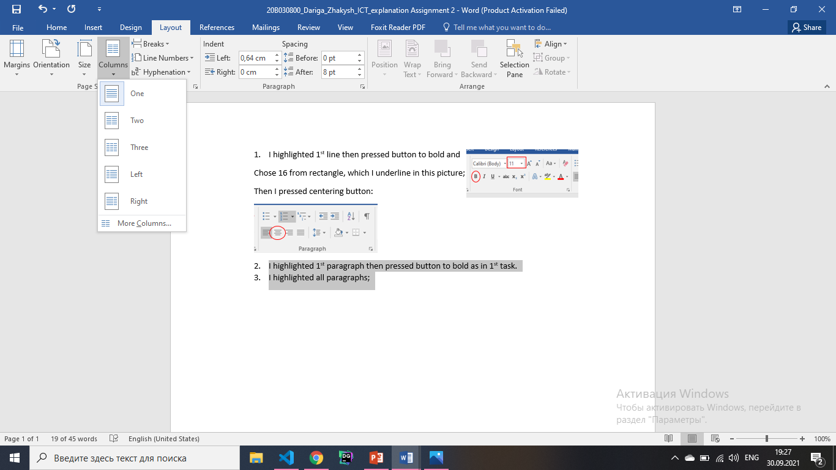I highlighted all paragraphs;

Then I went to the Layout;

Pressed columns->Two;

I had a two column of text then I pressed button of justify

As I did in 1st task (green rhombus);

So I find Times New Roman from this rectangle and

Changed space from this button;



1. To make first letter I highlighted it then I found from Insert->Drop Cap;

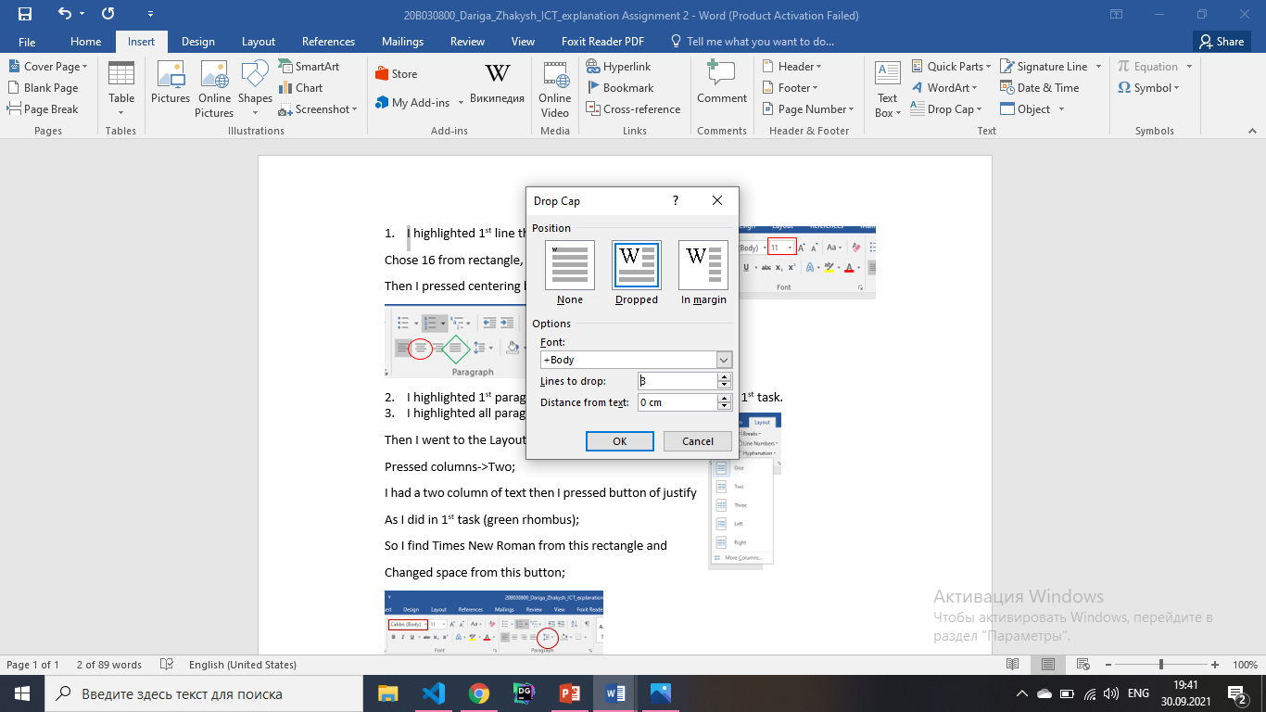 Then I chose 2 from “lines to drop”;

1. I highlighted images then centered as in 1st task; I highlighted text under image then chose 9 from button of changing size as in 1st task; Also I add words “Figure 1” and “Figure 2” for both text under the images;
2. To add a formula Insert->Equation->insert new equation: 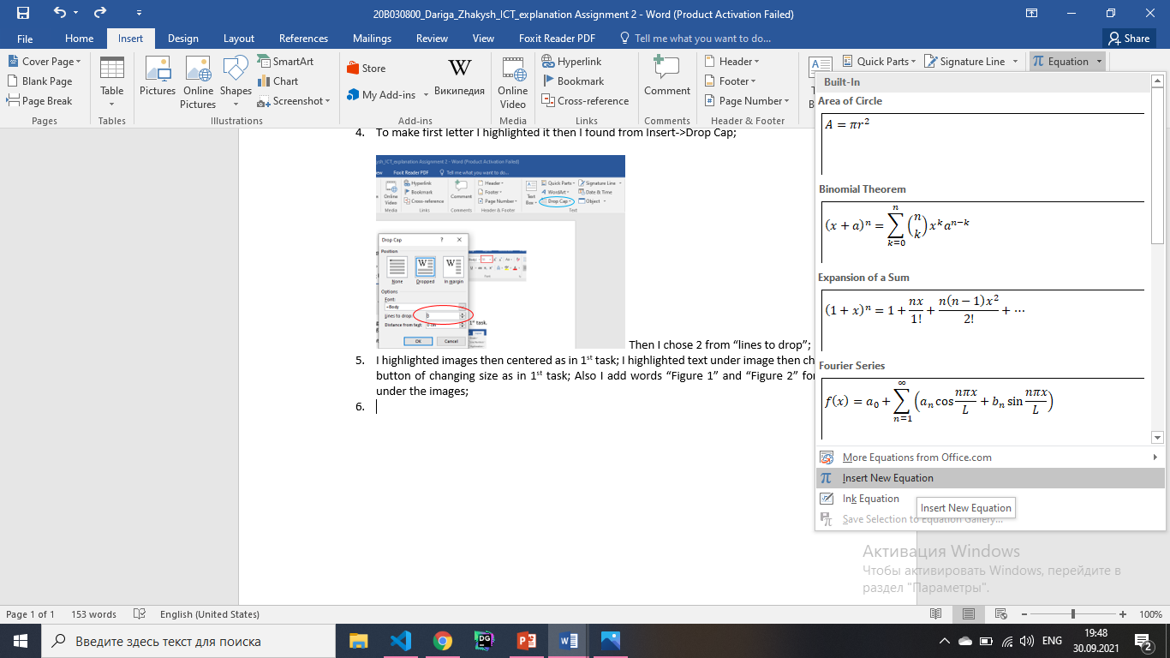

Then I type as in function with keyboard: to make index “_” or to make a power of “^” and etc.;

1. I add link with function Hyperlink and paste ctrl+v address;
2. Highl. words and from references->add footnate I add footnote and write some information;
3. Insert->Data&time I add updatable date and marked update automatically. Then I changed font size as in 1st task;
4. Insert->page number I added page number to the end of page also changed font size;

Excel:

Table1:

1. I pressed H then all result was highlighted: Conditional formatting -> Highlight cells rules-> greater than -> I write 50, also with less than. With them I chose green and red for passed and failed students respectively; so I didn’t do anything with ==50 because anything didn’t mention about this in tasks;
2. To count neighbor-students I need new sheet to make it easier for me; Then I pressed column of address Data->text to columns-> next-> space and I get separate 3 columns; I took 2 columns with all row without number: delete duplicates I get message how many I have duplicates. So I took this number;
3. I also create new sheet and took curren_ year and results, first_name, surname; I sort them Data->sort-> I add levels;
4. Ctrl+a I pressed filter->then near the result triangle->sort by color-> copy with red ctrl+c; then paste on new sheet;

Table 2:

1. I took women to another sheet; and add column age and today; then used formula DATADIF(DATA_OF_BIRTH;TODAY; “y”) then highlight column age then take average in formulas;
2. I found age of all players then I delete duplicates and found sum for every age amount of injuries; from this I took percentage;
3. I sorted table of women by pos.: then create a little table of positions and amount of players with quick analysis-> count - for every pos. then with this little table created pie chart;
4. Also I took unique ages and count players: then build scatter chart for all men;

Problem#1

I write input and output: And near the output: =IF(ISEVEN(B1);"YES";"NO") write this formula.

Because we need find is it even or odd to divide into two part: so if it is even it will output “YES”, otherwise “NO”;

Problem#2

I also write input and output: I have a three variables n, m, a:

n and m length of rectangle, a is length of flagstones;

I found with this formula amount of flagstones: =INT((B5+D5-1)/D5)*INT((C5+D5-1)/D5):

I can’t work only with area, because it's not allowed to break the flagstones: so I found how many need from length and width then multiple them.